Chapter 1
INTRODUCTION
With advancements in modern medicine and improved living standards, the global geriatric population is expanding at an unprecedented rate. According to the United Nations World Population Prospects, the proportion of individuals aged 60 and older is projected to double by 2050, reaching over 2.1 billion globally. In developing nations such as India, this demographic shift is intensified by rapid urbanization and the migration of young professionals for employment, accelerating the transition from traditional joint family structures to nuclear households. Consequently, an increasing number of senior citizens live alone or remain unassisted for extended periods during the day.
Aging is inherently accompanied by progressive physiological decline and an increased incidence of chronic degenerative illnesses, including cardiovascular disorders, hypertension, Type-2 diabetes, chronic obstructive pulmonary disease (COPD), and cognitive impairments. Managing these conditions requires continuous physiological observation, strict adherence to complex polypharmacy schedules, and rapid intervention during acute medical crises. However, traditional elderly care remains predominantly reactive and manual—relying on periodic physical visits, memory-based medication intake, and informal telephone check-ins. When elderly individuals live independently or their family guardians are geographically distant, subtle physiological deteriorations often go unnoticed until they escalate into acute medical emergencies, such as hypertensive crises, hypoxemia, or traumatic slip-and-fall injuries.
To address these compounding societal and technological challenges, G-Care (Guardian Remote Elder Care Dashboard & Clinic Portal) is developed as an integrated remote geriatric monitoring platform. G-Care bridges the critical communication and visibility gap between elderly individuals, their family guardians/caregivers, and consulting healthcare professionals by unifying edge-level hardware sensing with web-assisted clinical workflows.
The system combines a physical Internet of Medical Things (IoMT) hardware prototype built on a breadboard with a secure multi-portal web telecare platform:
- 1. Physical Hardware Sensing Node: An edge embedded system assembled on a breadboard utilizing an ESP32-S3 microcontroller, an optical MAX30102 Photoplethysmography (PPG) biosensor (for real-time Heart Rate and SpO2), a MAX30205 clinical-grade digital thermometer (for body temperature), an MPU6050 6-axis inertial motion tracking sensor (for fall and movement detection), and a local 0.96-inch OLED screen. The OLED display features a structured rectangular dashboard interface that continuously renders dynamic numeric vitals in real time, providing immediate feedback directly at the physical edge.
- Multi-Tier Web Platform: A responsive, type-safe web ecosystem comprising a Guardian/Caretaker Telemetry Dashboard, a Specialized Clinical Doctor Portal, an interactive Wearable Watch Simulator (for software verification and development), and a Smart TV Ambient Display Mode.
- Automated Anomaly Detection & Closed-Loop Care: Automated rule-based heuristics that continuously evaluate live physiological streams, detect critical threshold violations and falls, dispatch instantaneous audio-visual emergency alarms, track medication compliance with interactive check-offs, and deliver hands-free voice assistance in Indian regional languages (English, Hindi, Kannada, and Tamil).

1.1 Motivation
The conception and development of the G-Care platform is motivated by critical clinical, socioeconomic, and technological challenges:
- Vulnerability of Unmonitored Independent Seniors and the "Golden Hour": A substantial portion of senior citizens live alone while managing chronic comorbidities. Acute medical events—such as myocardial infarctions, sudden arrhythmias, hypertensive surges, or physical falls—frequently incapacitate seniors, rendering them unable to operate a telephone or call for assistance. Clinical outcomes deteriorate drastically when help is delayed; the critical "golden hour" for trauma and cardiac intervention is often lost. There is an urgent need for edge devices that detect abnormal physiological drops or physical impacts autonomously and dispatch immediate alerts.
- Need for Physical Edge Hardware with Direct Local Feedback: While purely software-based applications are common, elderly individuals require a tangible, physical edge device that monitors their vitals continuously without requiring them to navigate complex smartphone applications. Building a physical hardware breadboard prototype with a dedicated OLED display allows vitals (Heart Rate, ${\text{SpO}}_{2}$, Body Temperature) to be displayed in a clean, rectangular format in real time, giving seniors immediate reassurance regarding their health status.
- High Prevalence of Medication Non-Adherence: Geriatric patients are frequently prescribed complex, multi-drug regimens with varying dosages, dietary requirements (before/after meals), and administration times. Normal age-related cognitive decline and memory lapses lead to missed doses, incorrect timing, or accidental double dosing. Medication non-adherence is a primary driver of avoidable hospital readmissions and therapeutic failures.
- Fragmented Communication Between Guardians and Doctors: Traditional healthcare operates in disconnected silos. Family guardians often lack objective, continuous visibility into their loved one's daily health status, while consulting physicians only observe isolated, single-point measurements during brief hospital visits. Doctors lack the longitudinal telemetry and verified medication compliance histories necessary to calibrate prescriptions accurately.
- Digital Literacy and Linguistic Barriers in Healthcare Interfaces: The majority of contemporary health applications feature intricate touch navigation, dense text, small font sizes, and English-only menus. These design choices alienate elderly users, especially in multicultural regions. A viable elder-care system must incorporate high-contrast visuals, simplified typography, and natural language voice interactions in regional vernaculars.
- 6. Economic Inaccessibility of Commercial Telecare Solutions: Commercial medical-grade telecare devices and private assisted-living facilities are cost-prohibitive for the majority of middle- and lower-income families. G-Care demonstrates that an integrated telecare platform can be constructed using cost-effective, readily available embedded sensors and open web standards without compromising practical utility.

1.2 Objectives
The primary aim of this project is to conceptualize, design, and implement an end-to-end remote geriatric health monitoring and clinical management platform combining physical edge sensing with a multi-portal web dashboard.
The specific engineering and functional objectives are:
- Physical Edge Hardware Prototyping: To assemble and wire a functional physical hardware prototype on a solderless breadboard using an ESP32-S3 microcontroller, an optical MAX30102 PPG biosensor (measuring heart rate in BPM and oxygen saturation in ${\text{SpO}}_{2}\%$), a MAX30205 precision digital temperature sensor, and an MPU6050 6-axis accelerometer/gyroscope for motion and fall detection.
- Embedded OLED Rectangular Dashboard Interface: To design and program a dedicated firmware display driver on a $0.96\text{-inch}$monochrome ${\text{I}}^{2}\text{C}$OLED screen, structuring the layout into a high-contrast rectangular border with partitioned boxes displaying real-time, dynamic numeric streams for Heart Rate, ${\text{SpO}}_{2}$, and Temperature, alongside system status alerts.
- Real-Time Telemetry Tracking and Web Visualization: To engineer an interactive web telemetry engine capable of continuously ingesting, charting, and tracking multi-dimensional physiological metrics (Heart Rate, ${\text{SpO}}_{2}$, Blood Pressure, Body Temperature, Stress, and Hydration) using responsive Recharts time-series graphs and status indicators.
- Automated Anomaly Detection & Emergency SOS Protocols: To implement rule-based anomaly detection algorithms that evaluate continuous telemetry streams against clinical thresholds (categorizing states into Normal, Warning, and Critical), detect physical fall signatures from IMU acceleration spikes, and trigger immediate procedural audio alarms (Web Audio API), global visual alert banners, and emergency contact dispatches.
- Closed-Loop Medication and Routine Scheduling: To develop an interactive medication management module supporting custom frequencies (once daily, twice daily, PRN), time-triggered alerts, and an interactive checklist allowing caregivers and seniors to record administered doses for clinical compliance logging.
- Specialized Clinical Doctor Portal: To build an authenticated clinical workspace that enables physicians to evaluate longitudinal patient health trends, review medication compliance, upload and categorize diagnostic medical files (Complete Blood Counts, ECGs, scans, prescriptions), and author persistent clinical treatment notes.
- Multilingual Senior-Centric Voice Assistance: To integrate browser-native Web Speech synthesis and recognition supporting four languages (English, Hindi, Kannada, and Tamil) to speak medication reminders aloud and accept verbal confirmations, ensuring accessibility for seniors with visual or physical impairments.
- • Secure Role-Based Access Control (RBAC) & Data Persistence: To implement a secure RESTful API backend using Node.js, Express, Zod schema validation, and cryptographically signed JSON Web Tokens (JWT) with immediate token revocation upon logout, backed by a local JSON database fallback (data/db.json) with configurable relational database support.
Architectural Description:
- Physical Hardware & Edge Layer: The breadboard prototype acquires continuous biological signals through the MAX30102 pulse oximeter and MAX30205 temperature sensor, alongside spatial kinematic vectors from the MPU6050 IMU. The ESP32-S3 processes these signals locally, rendering real-time values inside a clean rectangular layout on the $0.96\text{-inch}$OLED display while transmitting telemetry packets to the backend. The software watch simulator runs in parallel for development and testing.
- Backend Application & Anomaly Processing Tier: Operates on an Express/Node.js pipeline. Incoming telemetry is validated through strict Zod contracts and evaluated by the anomaly detection engine. Validated metrics, medication regimens, and clinical files are persisted securely in the PostgreSQL / JSON database.
- Multi-Portal Presentation Tier: Renders role-specific Single-Page Application (SPA) interfaces for family guardians (live tracking, medication compliance, geofencing, ambient TV mode), attending physicians (diagnostic documents, longitudinal trends, clinical prescriptions), and emergency responders (immediate audible sirens and critical alert routing).
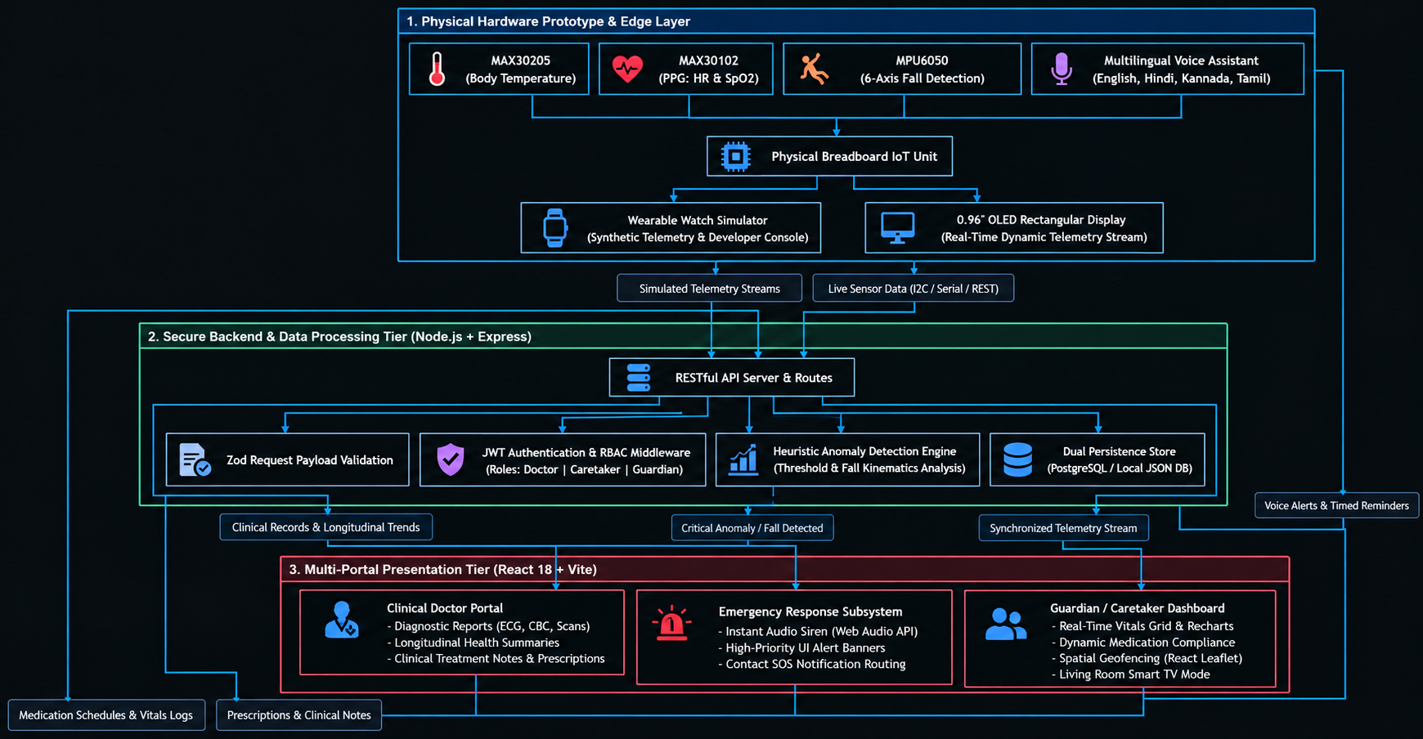
Figure 1.1: High-Level Conceptual Architecture and Dataflow of the G-Care Ecosystem

Chapter 2
LITERATURE REVIEW
The continuous expansion of the Internet of Medical Things (IoMT), wearable biosensors, and ubiquitous cloud computing has triggered a paradigm shift from traditional, episodic hospital care to decentralized, remote geriatric health monitoring. To construct an effective and user-centric platform such as G-Care, a comprehensive survey of contemporary literature was conducted across four foundational domains:
- IoT-driven remote patient monitoring architectures.
- Wearable biosensors for real-time physiological parameter estimation.
- Inertial sensor-based fall detection algorithms.
- Smart medication adherence systems and conversational voice interfaces for seniors.

2.1 Survey of Existing Literature and Methodologies
The literature is systematically reviewed and categorized according to the technical and functional dimensions of remote elderly healthcare.
2.1.1 IoT-Based Remote Patient Monitoring (RPM) Systems
- Islam et al. [1] presented a comprehensive survey on the application of the Internet of Things (IoT) in healthcare. The authors highlighted how edge-connected sensor nodes, wireless body area networks (WBANs), and centralized cloud repositories enable continuous tracking of vital parameters such as heart rate, peripheral oxygenation (${\text{SpO}}_{2}$), and ambient temperature. However, the survey revealed that most existing RPM systems suffer from fragmented architectures—they lack unified multi-tier interfaces that integrate the elder, their family caregivers, and clinical doctors simultaneously. Furthermore, data security, end-to-end access control, and low-latency anomaly dispatch mechanisms were identified as major recurring bottlenecks.
- Pantelopoulos and Bourbakis [2] conducted an extensive review of wearable sensor-based systems designed for health prognosis. They categorized non-invasive physiological sensors and analyzed data fusion algorithms used to establish patient baselines. While the study demonstrated the diagnostic efficacy of wearable telemetry, it underscored a significant gap: the majority of systems operate strictly in data-collection mode, offering minimal automated decision support, negligible medication compliance tracking, and complex interfaces that hinder real-world adoption by older adults.
- Majumder, Mondal, and Deen [3] analyzed wearable sensors for home-based telecare, focusing on wireless communication protocols (BLE, Wi-Fi, ZigBee) and energy harvesting. The authors noted that while hardware miniaturization has advanced, existing commercial and academic prototypes fail to provide unified emergency handling or automated alert verification, frequently leading to alert fatigue among caregivers.
2.1.2 Photoplethysmography (PPG) and Physiological Sensing
- Allen [4] investigated the physiological principles and clinical utility of Photoplethysmography (PPG) for estimating heart rate, arterial pulse wave velocity, and ${\text{SpO}}_{2}$. The research confirmed that optical biosensors (such as dual-wavelength red/infrared LED reflective sensors like the MAX30102) provide accurate, non-invasive cardiac telemetry suitable for low-power edge devices. Nevertheless, the study highlighted that raw PPG signals are highly susceptible to baseline wander and motion artifacts. It emphasized the necessity for software-level heuristics and threshold filters to validate physiological anomalies before triggering medical alerts.
2.1.3 Inertial Fall Detection and Emergency Alert Architectures
- Igual, Medrano, and Plaza [5] evaluated modern challenges in automated fall detection systems, categorizing methodologies into wearable sensor systems, ambient sensors, and computer vision techniques. They concluded that wearable tri-axial accelerometers and gyroscopes represent the most viable, privacy-preserving modality for geriatric monitoring. However, high rates of false positives during Activities of Daily Living (ADL)—such as sitting down abruptly or ascending stairs—remain a persistent challenge.
- Bourke, O'Brien, and Lyons [6] and de Miguel et al. [7] evaluated threshold-based algorithms applied to tri-axial accelerometer data (such as the MPU6050 sensor). Their experimental results proved that combining Upper Fall Thresholds (UFT) with secondary post-impact posture verification substantially reduces false alarms. The authors concluded that fall detection systems must be coupled with multi-channel dispatch frameworks (audible on-device alarms, cloud banners, and instant SOS caregiver notifications) to guarantee immediate medical response during the "golden hour."
2.1.4 Medication Adherence Systems and Senior Voice Interaction
- Goldstein et al. [8], Choudhry et al. [9], and Dai et al. [10] investigated the efficacy of electronic reminder devices and interactive prompts in improving medication compliance among elderly patients with chronic cardiovascular diseases. Randomized clinical trials proved that passive alarms (simple buzzers) achieve limited long-term adherence, whereas interactive reminders—requiring the user or caregiver to acknowledge dose administration—significantly improve therapeutic compliance and reduce preventable hospitalizations.
- Thakkar et al. [11] substantiated that bidirectional communication between patients and monitoring frameworks drastically enhances clinical outcomes in chronic disease management.
- Nallam et al. [12], Lifset et al. [13], and Morrow, Lane, and Rogers [14] explored the benefits and barriers of conversational AI and voice assistants among older adults. Their findings demonstrated that senior citizens often abandon health applications due to small font sizes, complex touch menus, and cognitive overload. Conversational agents and voice-based reminders significantly lowered the barrier to digital adoption. However, a critical limitation in existing solutions is the lack of regional language localization (such as Indian vernacular languages), which excludes rural and non-English-speaking geriatric demographics.

2.2 Comparative Analysis of Existing Healthcare Monitoring Systems
A comparative synthesis of existing market solutions, research prototypes, and the proposed G-Care platform is summarized in Table 2.1.
Table 2.1: Comparison Matrix of State-of-the-Art Solutions vs. Proposed G-Care Platform
Feature / Capability | Commercial Smartwatches (Apple Watch / Fitbit) | Clinical RPM Hardware (e.g., Philips Lifeline) | Traditional Hospital Portals | Academic IoT Prototypes | Proposed  G-Care Platform
Multi-Parametric Vitals (HR, ${\text{SpO}}_{2}$, BP, Temp) | Partial (HR & ${\text{SpO}}_{2}$only) | Minimal (Single-parameter) | Retrospective (Manual entry) | Partial (HR/Temp) | Full Suite (HR, ${\text{SpO}}_{2}$, BP, Temp, Stress, Hydration)
Real-Time Anomaly Detection | Proprietary on-device alerts | Call-center dispatch only | Absent (Static records) | Basic single-threshold | Heuristic Multi-Level (Normal, Warning, Critical)
Fall Detection & GPS Tracking | High accuracy, closed ecosystem | Wearable pendant only | Absent | Accelerometer-only (high false positives) | 6-Axis IMU Simulation + Geofencing + SOS
Tri-Tier RBAC Architecture | Disconnected (Single-user focus) | Caregiver-only | Doctor-only | Typically single-tier | Unified Tri-Tier (Doctor, Caretaker, Guardian)
Interactive Medication Planner | Basic reminder notification | Absent | E-Prescription only (No adherence log) | Standalone alarm | Closed-Loop Scheduler (Frequencies, logs, check-offs)
Diagnostic Document Repository | Absent | Absent | Proprietary EMR/EHR | Absent | Built-in Doctor Workspace (CBC, ECG, Scans, Notes)
Senior Multilingual Voice Support | English / Major global languages | Call center (Manual voice) | Text-based only | Rare | Multilingual Voice Assistant (EN, HI, KN, TA)
Living Room / Ambient Display | Absent | Absent | Absent | Absent | Dedicated Smart TV Feed Simulator
Deployment Cost & Accessibility | High hardware cost ($300–$800) | Expensive monthly subscription | Enterprise licensing fees | Low, but lacks software maturity | Cost-Effective, Open-Web Architecture

2.3 Research Gaps and Problem Formulation
A critical analysis of the literature reveals several fundamental deficiencies in contemporary geriatric care systems:
- Siloed Architectures and Lack of Multi-Stakeholder Collaboration: Most existing commercial and research platforms are designed either exclusively for the patient (wearable trackers) or exclusively for the clinician (hospital Electronic Health Records). The primary family caregiver/guardian—who is legally and emotionally responsible for daily care—is routinely omitted from the real-time feedback loop. There is a lack of unified platforms providing tailored, role-specific views for guardians, doctors, and seniors.
- Decoupled Vitals Tracking and Medication Adherence: Current monitoring applications track vital signs in complete isolation from prescription compliance. When an elder experiences an acute spike in blood pressure or pulse rate, physicians cannot ascertain whether the event is an organic clinical deterioration or simply the consequence of a missed antihypertensive dosage. Correlating vitals telemetry directly with verified medication check-offs represents an unaddressed necessity.
- Inadequate Emergency Dispatch Protocols and False Alarms: Stand-alone wearable sensors frequently trigger false emergency alerts during normal physical activities, leading to alert fatigue. Conversely, when an actual critical event occurs, systems often rely solely on push notifications that may go unnoticed. A multi-channel escalation framework—integrating persistent on-screen alerts, audio alarms, visual emergency banners, and direct contact routing—is absent in low-cost platforms.
- Linguistic and Digital Divide in Geriatric User Interfaces: Although voice technology has matured, existing health assistants are predominantly restricted to English and optimized for technologically literate demographics. In diverse societies like India, the absence of regional language voice support (such as Hindi, Kannada, and Tamil) severely restricts the accessibility and independence of elderly users.
- High Economic Barrier and Proprietary Vendor Lock-in: Proprietary clinical monitoring solutions entail steep upfront costs and recurring subscription charges, placing them out of reach for middle- and lower-income families. Furthermore, proprietary data silos prevent cross-platform data export and collaborative clinical review.

Problem Formulation
Based on the identified gaps, there is an urgent need for an integrated, affordable, and culturally accessible telecare ecosystem. The objective of this project is to bridge these gaps by developing G-Care: an end-to-end web-based platform that unifies simulated edge IoT telemetry, rule-based vitals anomaly detection, closed-loop medication scheduling, a specialized doctor clinical portal, and senior-centric multilingual voice assistance into a cohesive, secure, and cost-effective solution.

Chapter 3
SYSTEM ARCHITECTURE
The architecture of G-Care (Guardian Remote Elder Care Dashboard & Clinic Portal) is engineered as a secure, distributed, and multi-tier Internet of Medical Things (IoMT) system. It integrates a physical edge-sensing breadboard prototype, an embedded real-time OLED telemetry display, server-side data processing and anomaly detection, structured clinical storage, and role-differentiated client presentation.
The primary design principle is separation of concerns, ensuring that continuous high-frequency vitals telemetry streaming, asynchronous event detection (falls and geofence breaches), scheduled medication reminders, and heavy clinical document management operate reliably without inducing mutual latency or single points of failure.

3.1 Architectural Framework and Layered Organization
The G-Care platform is organized into five cohesive layers: the Edge Sensing and Telemetry Simulation Layer, the Communication and Network Layer, the Backend Application and Logic Tier, the Data Persistence Tier, and the Presentation Layer (Role-Based Portals).
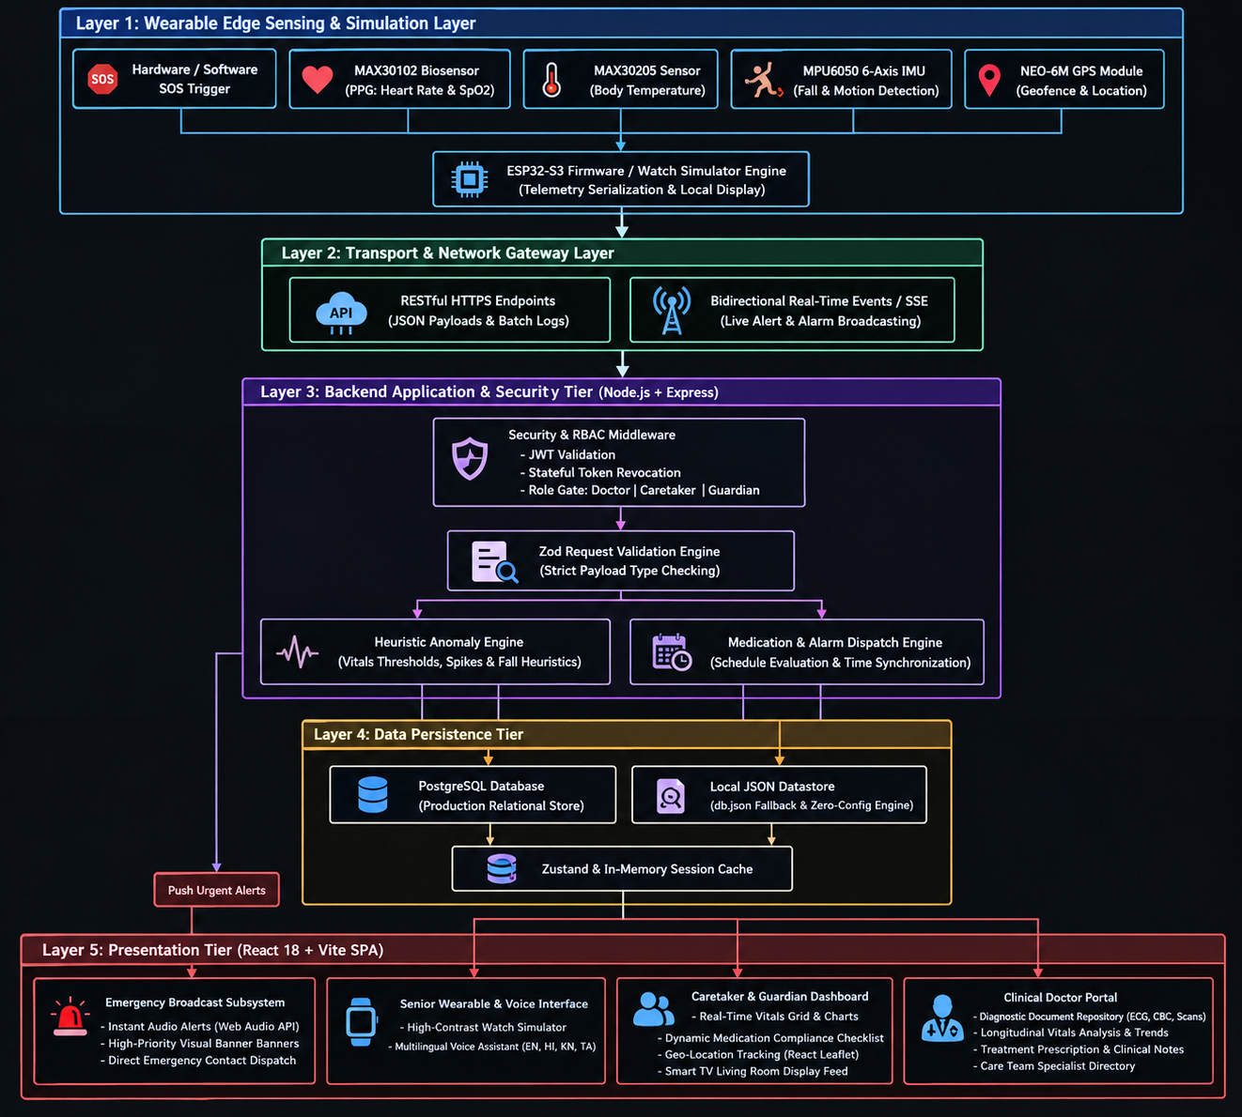
Figure 3.1: Multi-Tier Layered System Architecture of G-Care
3.2 Subsystem and Module Decomposition
The G-Care platform is modularized into seven interacting functional subsystems:
3.2.1 Physical Breadboard IoT Sensing Subsystem
- Constructed on a solderless breadboard controlled by an ESP32-S3 microcontroller.
- Houses three dedicated biosensors and an integrated display:
  - MAX30102 Biosensor: High-sensitivity red and infrared photoplethysmography sensor acquiring continuous pulse rates (40–180 BPM) and peripheral blood oxygen saturation (${\text{SpO}}_{2}$, 70–100%).
  - MAX30205 Clinical Thermometer: Digital human body temperature sensor providing clinical accuracy ($±{0.1}^{∘}\text{C}$).
  - MPU6050 6-Axis Motion Tracking Sensor: Tri-axial accelerometer and gyroscope sampling at $50\text{Hz}$to detect sudden impact vectors and orientation changes during physical falls.
  - 0.96-inch OLED Display: Structured with a continuous rectangular border and partitioned data boxes rendering real-time dynamic numeric streams for heart rate, ${\text{SpO}}_{2}$, and temperature directly to the user.
3.2.2 Real-Time Anomaly Detection Engine
- Implements multi-threshold and derivative analysis heuristics on live telemetry:
  - Heart Rate: Flagged as Warning if $<55\text{ BPM}$or $>100\text{ BPM}$; Critical if $<48\text{ BPM}$or $>120\text{ BPM}$.
  - ${\text{SpO}}_{2}$: Flagged as Warning if $<93\%$; Critical (severe hypoxemia) if $<90\%$.
  - Blood Pressure: Flagged if systolic $≥140\text{ mmHg}$or diastolic $≥90\text{ mmHg}$; Critical if systolic $≥160\text{ mmHg}$or diastolic $≥100\text{ mmHg}$.
  - Fall Events: Confirmed when acceleration magnitude $∣\vec{A}∣$exhibits a free-fall trough ($<0.5g$) followed by an impact spike ($≥3.0g$) and a static post-fall rest period.
- Automatically synthesizes procedural siren alerts via the Web Audio API and broadcasts high-priority visual warning banners to all connected guardian dashboards.
3.2.3 Medication and Routine Scheduling Subsystem
- Provides a structured scheduling engine supporting complex polypharmacy regimens:
  - Configures medicine names, dosages, instructions (before/after meals), and frequency patterns (once daily, twice daily, PRN/as needed).
  - Continuously evaluates client clock times against scheduled doses.
  - o Interactive compliance verification: guardians or elders mark doses as "Taken" or "Missed" in the interface, updating the active adherence status for caregiver review.
3.2.4 Caretaker and Guardian Telemetry Dashboard
- Central command center for family members:
  - Live Vitals Grid: Real-time visual cards displaying current metrics with color-coded status badges.
  - Longitudinal Trends: Historical metric charting powered by Recharts (line and area charts spanning hours, days, or weeks).
  - Living Room / TV Mode: High-contrast, large-format interface optimized for smart TV displays, enabling continuous ambient room monitoring.
  - Geofence Map: Interactive spatial tracking powered by React Leaflet showing the elder's real-time position within designated safe zones.
3.2.5 Clinical Doctor Portal & Diagnostic Workspace
- A specialized workspace for registered medical practitioners:
  - Diagnostic Record Repository: Allows uploading, categorizing, and previewing diagnostic files (ECGs, Complete Blood Counts, MRI/CT scans, prescriptions) with thumbnail badges and metadata.
  - Clinical Recommendations Log: A rich-text clinical note editor to write, update, and persist clinical directives, dosage alterations, and follow-up consultation dates.
  - Care Team Directory: Collaborative roster listing primary care physicians, cardiologists, and emergency hospital clinics linked to the patient profile.
3.2.6 Senior-Centric Accessibility & Multilingual Voice Subsystem
- Incorporates the Web Speech API (SpeechSynthesis and SpeechRecognition) coupled with an i18n localization store.
- Supports four regional languages: English, Hindi, Kannada, and Tamil.
- Speaks out incoming medicine reminders, daily routine prompts, and emergency warnings aloud.
- Accepts basic voice commands to confirm medication intake or query current vitals, addressing physical and cognitive limitations of senior users.
3.2.7 Security, Authentication, and RBAC Subsystem
- Enforces Role-Based Access Control (doctor, caretaker, guardian) using cryptographically signed JSON Web Tokens (JWT).
- Utilizes a stateful token revocation blacklist in memory/database to invalidate tokens immediately upon logout.
- Validates all incoming API payloads using strict schema definitions (Zod), rejecting malformed packets or unauthorized role elevation attempts.

3.3 Data Flow and System Interaction Modeling
3.3.1 Level 0: Context Data Flow Diagram
The Level 0 Context DFD establishes the operational boundaries of the G-Care platform, illustrating the interactions between external entities (Breadboard Hardware Node, Senior, Guardian/Caretaker, Doctor, and Emergency Responders) and the centralized G-Care System.
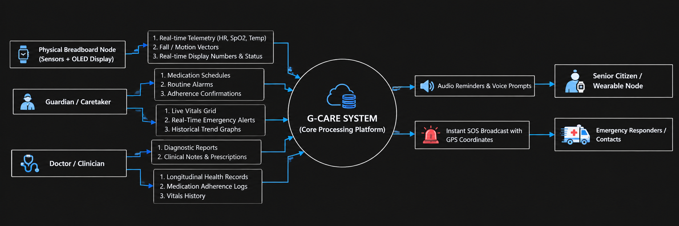
Figure 3.2: DFD Level 0 — Context Level Diagram
3.3.2 Level 1: Functional Data Flow Diagram
The Level 1 DFD decomposes the system into core internal processes, tracing data transformation across telemetry ingestion, anomaly analysis, medication scheduling, clinical management, and persistent storage.

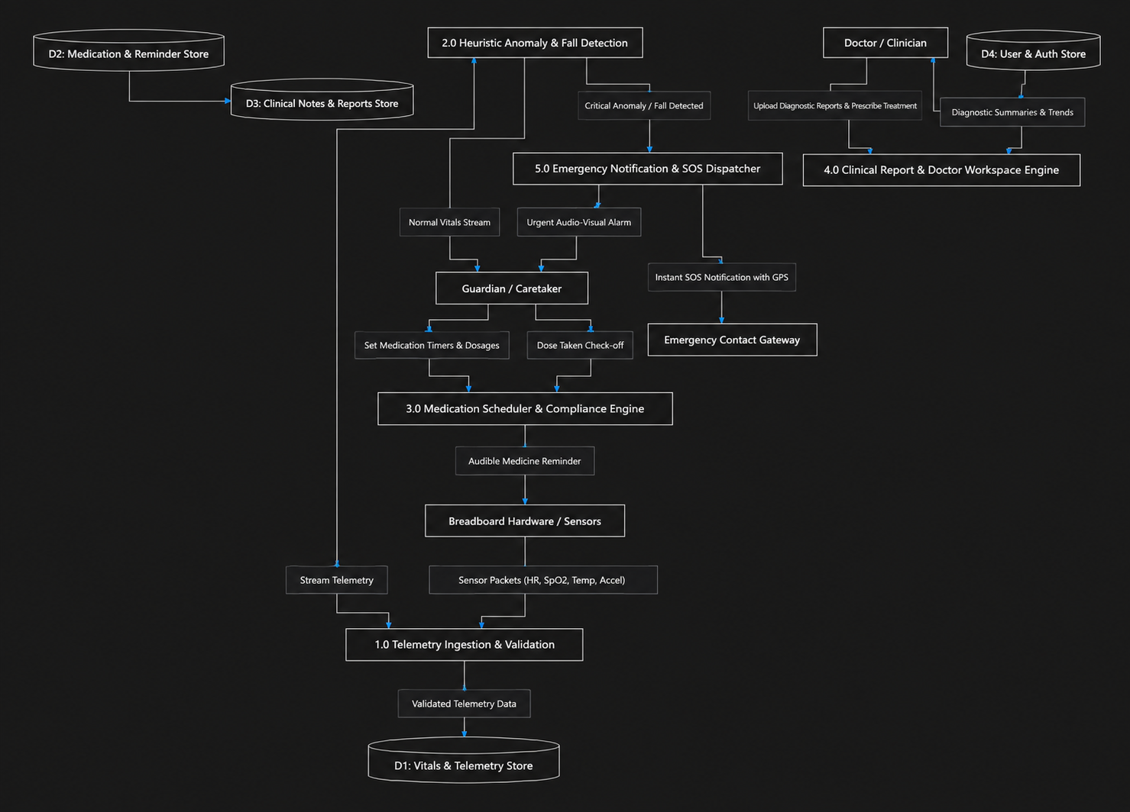
Figure 3.3: DFD Level 1 — Detailed Functional Data Flow Diagram

Chapter 4
SYSTEM REQUREMENTS
Defining the system requirements establishes the technical and operational boundaries necessary to build, deploy, and execute the G-Care (Guardian Remote Elder Care Dashboard & Clinic Portal) platform. These requirements are divided into:
- Hardware Requirements (Physical breadboard prototyping components, edge sensors, display module, host machine, and client devices).
- Software Requirements (Embedded firmware tooling, web application frameworks, state engines, databases, and APIs).
- Functional and Non-Functional Requirements (System behavioral features, latency metrics, accessibility standards, and data security contracts).

4.1 Hardware Requirements
The hardware requirements encompass the physical embedded edge prototype assembled on the breadboard, the development environment, and client viewing terminals.
4.1.1 Physical Breadboard IoT Prototype Specifications
Table 4.1: Edge Hardware and Prototyping Components
Component | Model / Specification | Functional Role in G-Care
Prototyping Platform | Half-Size Solderless Breadboard (400 tie-points) + Male-to-Male / Male-to-Female Jumper Wires | Base physical prototyping surface interconnecting sensor breakout boards, display, and power distribution rails.
Main Microcontroller | ESP32-S3-WROOM-1 (Dual-core 32-bit Xtensa LX7 @ 240 MHz, 512 KB SRAM, Wi-Fi & BLE 5.0) | High-speed edge controller orchestrating sensor polling over $I^{2}C$, running local fall filtering, driving OLED display, and sending telemetry.
Optical PPG Biosensor | MAX30102 Integrated Pulse Oximeter & Heart-Rate Sensor | Emits dual-wavelength red ($660\text{nm}$) and infrared ($880\text{nm}$) light to measure pulse rate (40–180 BPM) and blood oxygen saturation (${\text{SpO}}_{2}$, 70–100%).
Clinical Temperature Sensor | MAX30205 Human Body Temperature Sensor | Provides high clinical accuracy ($±{0.1}^{∘}\text{C}$ over ${37}^{∘}\text{C}$to ${39}^{∘}\text{C}$) via ${\text{I}}^{2}\text{C}$digital output to detect hypothermia or fever.
Inertial Motion Unit (IMU) | MPU6050 6-Axis Motion Tracking (Tri-axial Accelerometer + Tri-axial Gyroscope) | Samples acceleration and angular velocity at $50\text{Hz}$to detect rapid impact vectors ($>3.0g$) and post-fall rest states.
Local Visual Display | 0.96-inch OLED Display ($128×64$ pixels, ${\text{I}}^{2}\text{C}$, SSD1306 driver) | Renders a structured rectangular dashboard interface displaying real-time dynamic numeric values for HR, ${\text{SpO}}_{2}$, and Temperature.
Pull-Up Resistors | $4.7\text{k}Ω$Metal Film Resistors | Pull-up resistors on SDA (GPIO 21) and SCL (GPIO 22) lines to maintain $I^{2}C$bus signal integrity across multiple sensor nodes.
Power Supply | 5V DC via Micro-USB / Type-C or 3.7V $800\text{mAh}$Li-Po battery with 3.3V LDO regulator | Delivers clean, regulated 3.3V DC power to the microcontroller and all sensor modules on the breadboard.
4.1.2 Development, Server, and Client Workstation Requirements
- Processor: Intel Core i5 / AMD Ryzen 5 (quad-core, $≥2.4\text{GHz}$) or Apple Silicon M-series.
- System Memory (RAM): Minimum $8\text{GB}$(16 GB recommended for concurrent client, server, and local database execution).
- Storage Space: Minimum $20\text{GB}$available Solid-State Drive (SSD) capacity.
- Network Interface: Standard 802.11ac/ax Wi-Fi or Gigabit Ethernet connection ($≥10\text{Mbps}$).
- Client Viewing Terminals:
  - Desktop / Laptop display with minimum screen resolution of $1366×768$pixels (1080p Full HD recommended).
  - Tablet or Smartphone display (iOS / Android) with modern HTML5-compliant mobile web browser.
  - Smart TV display ($1920×1080$ Full HD or $4\text{K}$) for living room ambient monitor mode.

4.2 Software Requirements
The platform is constructed on modern web standards and embedded C++ libraries, utilizing type-safe languages across all tiers.
Table 4.2: Software Technology Stack
Domain | Technology / Tool | Version / Release | Role in G-Care System
Operating System | Windows 10/11, Ubuntu Linux 22.04 LTS, or macOS | 64-bit Architecture | Base development and server hosting operating system.
Embedded Firmware IDE | Arduino IDE / PlatformIO | v2.3+ | Writing, compiling, and flashing C++ firmware to the ESP32-S3 microcontroller.
Display & Sensor Libraries | Adafruit_SSD1306, Adafruit_GFX, Wire.h | Latest Stable | Controlling the $I^{2}C$bus and drawing the rectangular UI layout and dynamic numbers on the OLED screen.
Frontend Framework | React.js | v18.3+ | Component-driven user interface architecture with declarative UI rendering.
Language & Typings | TypeScript | v5.5+ | Enforces compile-time type safety across UI models, API responses, and store schemas.
Build & Bundler Tool | Vite | v8.0+ | Fast build engine with Hot Module Replacement (HMR) and optimized tree-shaken production bundling.
CSS & Design System | Tailwind CSS + shadcn/ui | v3.4+ / Radix Primitives | Utility-first responsive styling framework with accessible, high-contrast UI primitives.
State Management | Zustand | v4.5+ | Lightweight, reactive global store managing real-time vitals, medication states, and session tokens.
Data Visualization | Recharts | v2.12+ | Composable charting library rendering responsive time-series graphs for heart rate, ${\text{SpO}}_{2}$, and blood pressure.
Spatial Mapping | React Leaflet + Leaflet.js | v4.2+ / v1.9+ | Interactive mapping interface rendering elder GPS coordinates, safe-zone markers, and geofence radii.
Voice & Speech APIs | Web Speech API + Web Audio API | W3C Standard | Implements browser-native voice synthesis (SpeechSynthesis), voice recognition, and procedural alarm generation.
Backend Runtime | Node.js | v18.x / v20.x LTS | Asynchronous, event-driven JavaScript server runtime.
Web Server Framework | Express.js | v4.19+ | Lightweight HTTP server handling RESTful routing, middleware pipelines, and API endpoints.
Payload Validation | Zod | v3.23+ | Schema declaration and static type inference validating incoming API payloads against strict data contracts.
Authentication & Tokens | JSON Web Tokens (JWT) + bcryptjs | jsonwebtoken v9.0+ | Stateless signed authentication with password hashing and stateful token revocation on logout.
Database Systems | PostgreSQL (Production) / db.json (Fallback) | PostgreSQL 14+ / Node FS | Relational data persistence for users, clinical notes, and reports, with local JSON file fallback for offline execution.
Testing Frameworks | Vitest, Playwright | Latest Stable | Automated unit and integration testing of stores, APIs, and anomaly triggers.

4.3 Functional and Non-Functional Requirements
4.3.1 Functional Requirements (FR)
- FR1: Physical Sensor Acquisition and Local Rectangular Display
  - The physical hardware prototype must continuously sample Heart Rate and ${\text{SpO}}_{2}$(MAX30102), Body Temperature (MAX30205), and Motion/Fall Vectors (MPU6050).
  - The $0.96\text{-inch}$OLED display must render a high-contrast rectangular border framing dedicated partitioned boxes that update dynamic numeric values continuously in real time.
- FR2: Role-Based Authentication and Session Control
  - The system must authenticate users under three distinct roles: doctor, caretaker, and guardian.
  - The system must issue cryptographically signed JWT tokens and maintain a token-revocation store that invalidates tokens immediately upon user sign-out.
- FR3: Multi-Parametric Telemetry Ingestion and Web Monitoring
  - The web platform must ingest, process, and display vital metrics in real time: Heart Rate (BPM), Blood Oxygen Saturation (${\text{SpO}}_{2}$), Blood Pressure, Body Temperature (${}^{∘}\text{C}$), Stress, and Hydration.
- FR4: Real-Time Anomaly Detection and Emergency Dispatch
  - The system must continuously evaluate live vitals against clinical thresholds and classify states as Normal, Warning, or Critical.
  - The system must detect physical fall events and geofence boundary deviations.
  - Upon detection of a Critical anomaly or manual SOS activation, the system must trigger visual alert banners, audible alarm frequencies, and emergency notifications.
- FR5: Medication Management and Adherence Logging
  - The system must allow guardians to configure medication regimens with customizable names, dosages, instructions, and frequency selectors (once daily, twice daily, PRN).
  - The system must trigger time-matched alerts and provide an interactive checklist enabling users to record doses as "Taken" or "Missed" for compliance tracking.
- FR6: Clinical Workspace and Diagnostic Document Repository
  - The system must enable physicians to inspect longitudinal vitals graphs, review medication compliance, and upload/categorize diagnostic files (CBC, ECG, radiology scans, prescriptions).
  - The system must provide a clinical note editor for physicians to author and persist treatment directives and follow-up schedules.
- FR7: Multilingual Senior Voice Assistance & Smart TV Mode
  - The system must provide a voice assistant capable of speaking reminder notifications and responding to basic voice queries in four languages: English, Hindi, Kannada, and Tamil.
  - The system must provide a living room ambient display mode optimized for smart TVs.
4.3.2 Non-Functional Requirements (NFR)
- NFR1: Performance and Low Latency
  - The OLED display must refresh at $≥2\text{Hz}$to render continuous dynamic vitals smoothly.
  - The client web dashboard must reflect live telemetry updates within $500\text{ms}$of transmission.
  - Anomaly detection heuristics must evaluate incoming telemetry packets in under $50\text{ms}$.
- NFR2: Reliability, Availability, and Fault Tolerance
  - The backend API server must maintain $99.9\%$operational uptime.
  - In the event of PostgreSQL database connectivity interruption, the system must automatically fall back to local file-backed JSON storage (data/db.json) to prevent data loss.
- NFR3: Usability and Senior-Centric Accessibility
  - The user interface must adhere to WCAG 2.1 Level AA standards: minimum body text size of $16\text{–}18\text{px}$, high-contrast color palettes ($≥4.5:1$ contrast ratio), and large touch targets ($≥48×48\text{px}$).
- NFR4: Security, Data Integrity, and Confidentiality
  - All communications between client terminals and backend endpoints must be transmitted over encrypted HTTPS/TLS. Passwords must be salted and hashed using bcrypt.
  - All incoming payloads must undergo strict schema validation via Zod to prevent injection and tampering.
- NFR5: Portability and Cross-Platform Compatibility
  - The responsive web frontend must render consistently across modern desktop and mobile browsers (Google Chrome, Mozilla Firefox, Microsoft Edge, Safari).

Chapter 5
METHODOLOGY
This chapter details the operational methodology and formal system design of G-Care (Guardian Remote Elder Care Dashboard & Clinic Portal).
Section 5.1 outlines the end-to-end algorithmic and procedural methodology governing sensor data acquisition, dual-threshold anomaly detection, fall kinematics, and closed-loop medication workflows. Section 5.2 presents the concrete system design artifacts, including the physical breadboard $I^{2}C$circuit design, the rectangular OLED screen layout, the Entity-Relationship (ER) database schema, and Use Case behavioral models.

5.1 Proposed Methodology and Operational Flow
The G-Care methodology follows a reactive, event-driven pipeline organized into five sequential stages:
- Physical Breadboard Sensor Telemetry Acquisition & Filtering.
- Dual-Threshold Anomaly Detection and Fall Kinematics Analysis.
- Closed-Loop Medication Adherence State Machine.
- Emergency Alert Escalation & Broadcast Dispatch.
- Multilingual Natural Speech Interaction Pipeline.

5.1.1 Physical Breadboard Telemetry Acquisition and Signal Processing
Telemetry is continuously sampled from the physical breadboard hardware at $50\text{Hz}$for inertial motion and $10\text{Hz}$for optical biosignals:
- Optical PPG Processing: Raw infrared and red AC/DC signal ratios from the MAX30102 are processed using a moving average window ($N=16\text{samples}$) to eliminate baseline wander and high-frequency motion artifacts.
- Temperature Calibration: The MAX30205 delta-sigma ADC outputs digital temperature registers, filtered to ${0.1}^{∘}\text{C}$resolution.
- Telemetry Data Frame: Formatted into a standardized JSON payload: $T=\left\{\text{elder}\text{_}\text{id} , \text{timestamp} , \text{HR} , {\text{SpO}}_{2} , {\text{BP}}_{\text{sys}} , {\text{BP}}_{\text{dia}} , \text{Temp} , \text{Stress} , \text{Hydration} , \vec{A} , \vec{ω}\right\}$

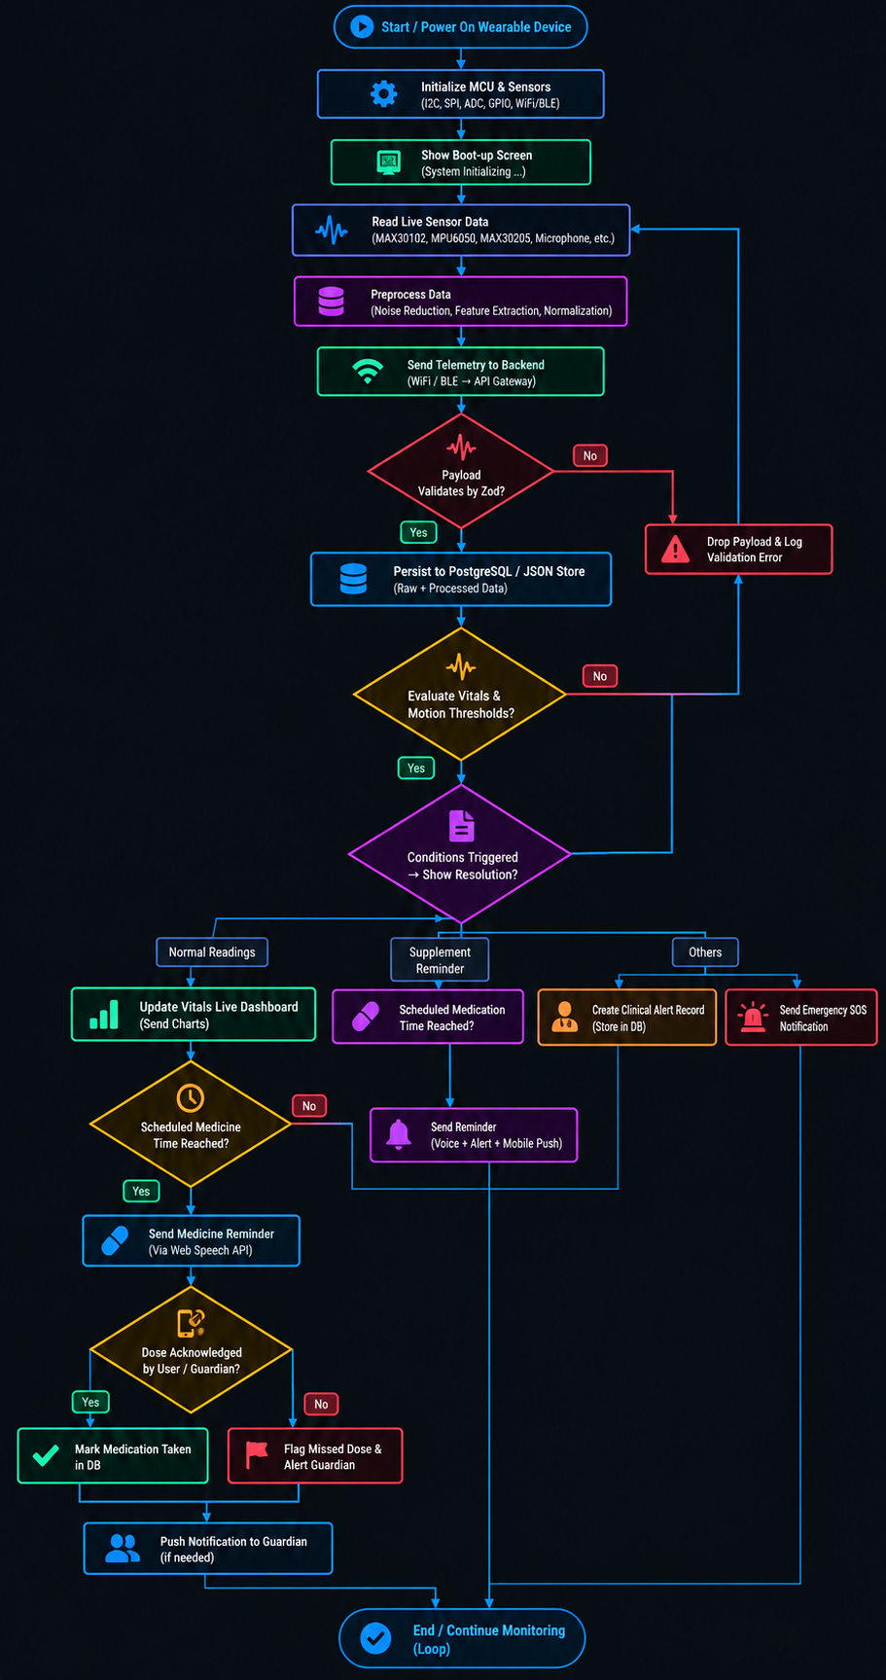
Figure 5.1: End-to-End Operational Methodology Flowchart of G-Care
5.1.2 Dual-Threshold Anomaly and Kinematics Heuristics
The heuristic engine evaluates vital parameters against clinical safety intervals and classifies severity into Normal, Warning, or Critical:
- Heart Rate Evaluation ($\text{HR}$ in BPM):
$$\text{Severity}\left(\text{HR}\right)=\left\{\begin{matrix}\text{Critical (Severe Tachycardia)}, & \text{HR}>120 \\ \text{Warning (Elevated Pulse)}, & 100<\text{HR}≤120 \\ \text{Normal}, & 55≤\text{HR}≤100 \\ \text{Warning (Bradycardia)}, & 48≤\text{HR}<55 \\ \text{Critical (Severe Bradycardia)}, & \text{HR}<48\end{matrix}\right.$$
- Peripheral Oxygen Saturation (${\text{SpO}}_{2}$ in %):
$$\text{Severity}\left({\text{SpO}}_{2}\right)=\left\{\begin{matrix}\text{Normal}, & 94\%≤{\text{SpO}}_{2}≤100\% \\ \text{Warning (Suboptimal Saturation)}, & 90\%≤{\text{SpO}}_{2}<94\% \\ \text{Critical (Acute Hypoxemia)}, & {\text{SpO}}_{2}<90\%\end{matrix}\right.$$
- Inertial Fall Detection Kinematics: Acceleration vector magnitude $∣\vec{A}∣$is continuously computed from tri-axial accelerometer vectors: $∣\vec{A}∣=\sqrt{A_{x}^{2}+A_{y}^{2}+A_{z}^{2}}$A fall event is confirmed if a severe impact spike ($∣\vec{A}∣≥3.0g$) is preceded by free-fall weightlessness ($∣\vec{A}∣≤0.5g$) and followed by a stationary post-fall posture period ($Δθ≥{60}^{∘}$ for $>5\text{seconds}$).
- Alert De-bouncing Logic: To prevent alert fatigue, duplicate warning alerts for the same metric are suppressed during a sliding cooldown window ($T_{\text{cooldown}}=60\text{seconds}$), unless an event escalates from Warning to Critical.

5.2 Detailed System Design and Schema Modeling
5.2.1 Physical Breadboard $I^{2}C$Bus and Hardware Interfacing Design
The physical hardware prototype is implemented on a half-size solderless breadboard. All peripheral modules share a common two-wire $I^{2}C$serial bus:
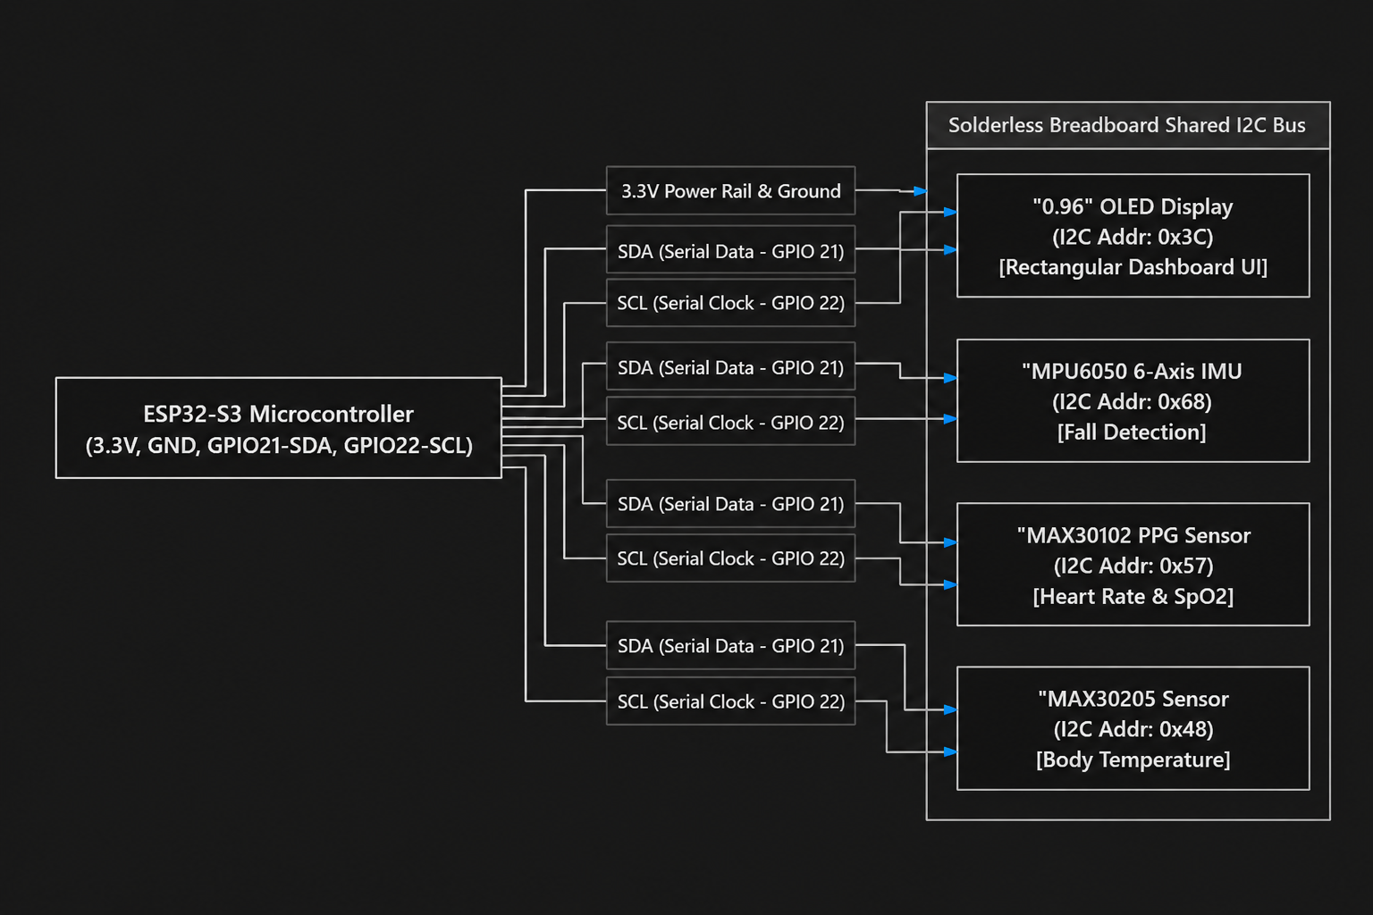
Figure 5.2: Shared $I^{2}C$Bus Interfacing on Prototype Breadboard
$I^{2}C$Bus Addressing and Multiplexing
All four peripheral modules communicate over a shared two-wire $I^{2}C$bus operating at $400\text{kHz}$Fast Mode:
- OLED Display (SSD1306): Slave address 0x3C
- MAX30102 Pulse Oximeter: Slave address 0x57
- MAX30205 Clinical Thermometer: Slave address 0x48
- MPU6050 Inertial Measurement Unit: Slave address 0x68

5.2.2 OLED Screen Rectangular UI Layout Design
The $0.96\text{-inch}$monochrome OLED display ($128×64$ pixels) is designed with a structured rectangular dashboard layout to ensure high legibility for senior users:
- Outer Rectangular Boundary: A continuous border drawn from coordinate $\left(0 , 0\right)$to $\left(127 , 63\right)$framing the display.
- Top Header (0 to 14 px): System title (G-CARE MONITOR) with dividing horizontal separator line.
- Partitioned Vitals Matrix (15 to 50 px):
  - Heart Rate Row: Dynamic numeric pulse stream updated in real time (HR : 76 bpm).
  - ${\text{SpO}}_{2}$Row: Real-time oxygen saturation percentage (SpO2: 98 %).
  - Temperature Row: Continuous clinical temperature reading (TEMP: 36.8 C).
- Lower Status Footer (51 to 63 px): Separated footer indicating system health: STATUS: NORMAL or flashing ! FALL DETECTED !.

5.2.3 Entity-Relationship (ER) Schema Modeling
The data layer is modeled relationally to guarantee referential integrity across users, elderly patient profiles, longitudinal vitals telemetry, medication schedules, and clinical reports.
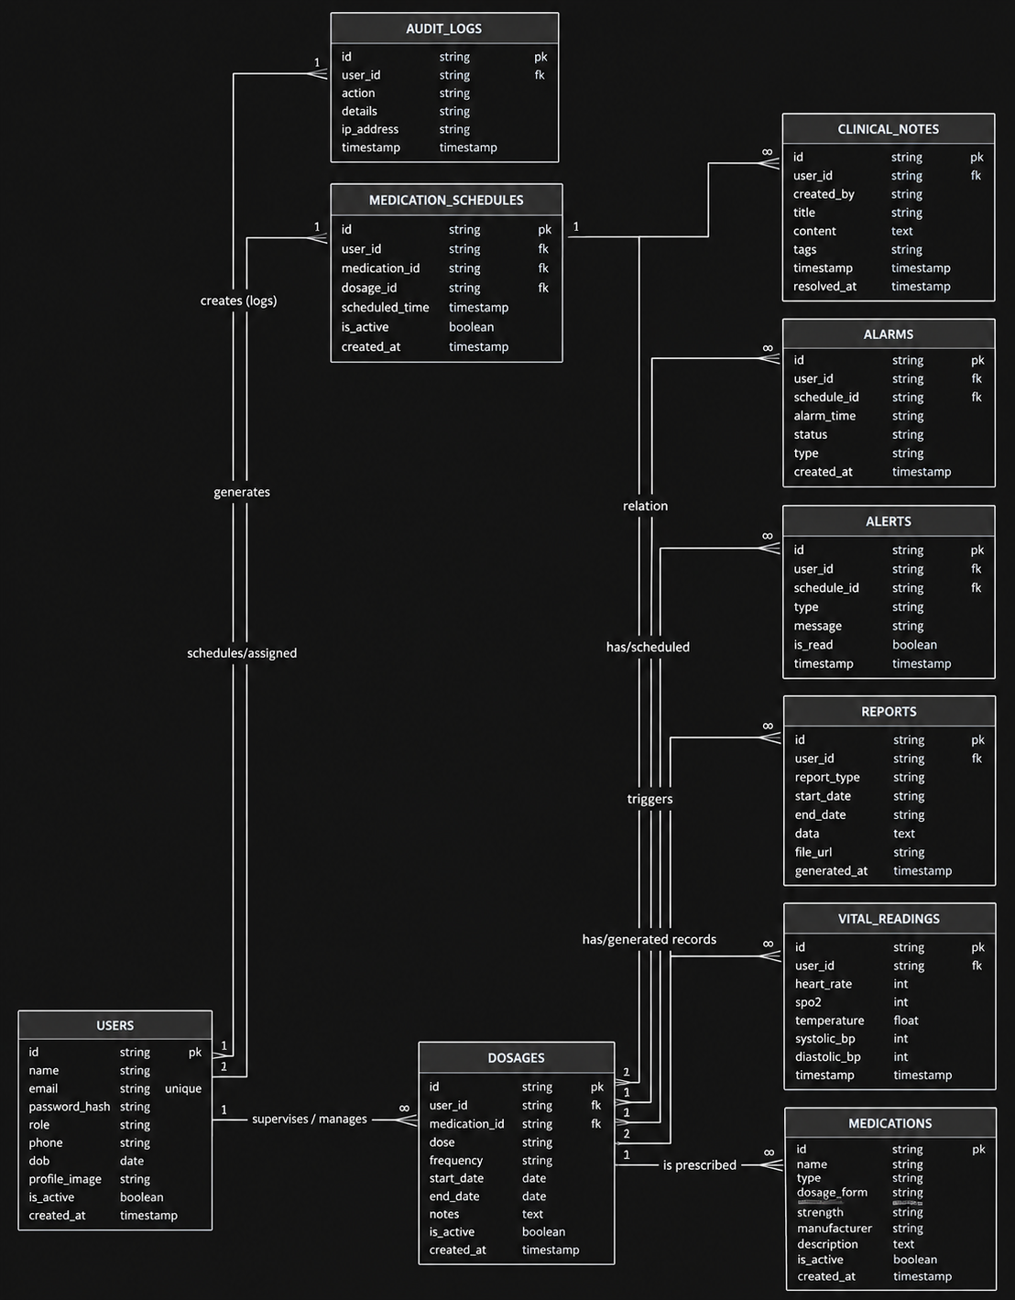
Figure 5.3: Entity-Relationship Diagram of G-Care Platform
5.2.4 Use Case Modeling
The behavioral interactions between the system's human and device actors are formalized in the Use Case model:
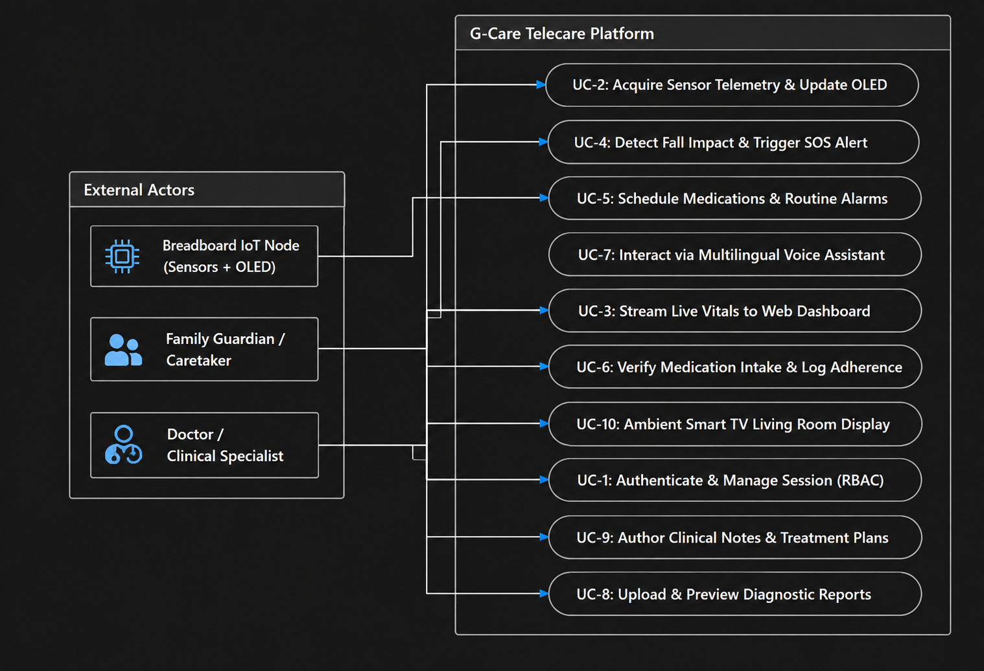
Figure 5.4: Use Case Diagram for the Tri-Tier G-Care System

Chapter 6
IMPLEMENTATION
This chapter details the technical implementation of G-Care (Guardian Remote Elder Care Dashboard & Clinic Portal).
Section 6.1 covers the physical breadboard hardware wiring, OLED display firmware, client web presentation, Zustand state stores, and clinical workspace modules. Section 6.2 formalizes the system's operational logic through rigorous algorithms and pseudocode. Section 6.3 describes the security controls, API contract validation using Zod, and the hybrid database persistence mechanism.

6.1 Implementation of Core Functional Modules
6.1.1 Physical Breadboard Hardware Prototype and Sensor Integration
A functional physical hardware prototype was implemented on a half-size solderless breadboard. This prototype validates edge sensor signal acquisition, on-device signal processing, and direct local visual telemetry feedback.
Table 6.1: Breadboard Pin Interfacing and Wiring Connections
Sensor / Module | Module Pin | ESP32-S3 Microcontroller Pin | Description
Common Power Rail | VCC / VIN | 3V3 Pin (3.3V DC) | Regulated positive voltage rail for all sensors.
Common Ground Rail | GND | GND Pin | Common ground reference across breadboard.
0.96" OLED Display | VCC, GND | 3.3V Rail, GND Rail | Power lines for SSD1306 driver.
 | SDA | GPIO 21 | $I^{2}C$Serial Data for display buffer.
 | SCL | GPIO 22 | $I^{2}C$Serial Clock line ($400\text{kHz}$).
MAX30102 (HR & ${\text{SpO}}_{2}$) | VIN, GND | 3.3V Rail, GND Rail | Optical biosensor power supply.
 | SDA | GPIO 21 | Shared $I^{2}C$Serial Data line.
 | SCL | GPIO 22 | Shared $I^{2}C$Serial Clock line.
 | INT | GPIO 19 | Active-low hardware interrupt for sample ready.
MAX30205 (Temp) | VDD, GND | 3.3V Rail, GND Rail | Precision body temperature sensor power.
 | SDA, SCL | GPIO 21, GPIO 22 | Shared $I^{2}C$bus.
MPU6050 (Fall IMU) | VCC, GND | 3.3V Rail, GND Rail | 6-axis accelerometer/gyroscope power.
 | SDA, SCL | GPIO 21, GPIO 22 | Shared $I^{2}C$bus.
 | INT | GPIO 18 | Motion interrupt pin to signal sudden shock/fall.
6.1.2 Embedded OLED Rectangular Display Firmware Implementation
The firmware running on the ESP32-S3 controls the screen rendering loop using the Adafruit_SSD1306 and Adafruit_GFX libraries. The code establishes a continuous polling routine that reads raw sensor values, calculates moving averages to filter physiological noise, and continuously refreshes the dynamic numbers inside the rectangular UI template:
#include <Wire.h>
#include <Adafruit_GFX.h>
#include <Adafruit_SSD1306.h>
#define SCREEN_WIDTH 128
#define SCREEN_HEIGHT 64
#define OLED_RESET -1
Adafruit_SSD1306 display(SCREEN_WIDTH, SCREEN_HEIGHT, &Wire, OLED_RESET);
void setup() {
Wire.begin(21, 22); // Initialize I2C bus: SDA=21, SCL=22
display.begin(SSD1306_SWITCHCAPVCC, 0x3C);
display.clearDisplay();
}
void loop() {
// 1. Read real-time telemetry from physical sensors
int heartRate = readMAX30102HeartRate(); // Dynamic real-time pulse (e.g. 72-78 bpm)
int spo2Level = readMAX30102SpO2(); // Dynamic SpO2 level (e.g. 97-99 %)
float bodyTemp = readMAX30205Temperature(); // Precision temp (e.g. 36.7 C)
bool fallDetected = checkMPU6050Fall();
// 2. Render Rectangular Dashboard UI
display.clearDisplay();

// Outer frame boundary
display.drawRect(0, 0, 128, 64, SSD1306_WHITE);

// Header section
display.setTextSize(1);
display.setTextColor(SSD1306_WHITE);
display.setCursor(18, 4);
display.print("G-CARE MONITOR");
display.drawLine(0, 14, 127, 14, SSD1306_WHITE);
// Vitals Grid Boxes
// Box 1: Heart Rate
display.setCursor(6, 20);
display.print("HR : ");
display.print(heartRate);
display.print(" bpm");
// Box 2: SpO2
display.setCursor(6, 32);
display.print("SpO2: ");
display.print(spo2Level);
display.print(" %");
// Box 3: Temperature
display.setCursor(6, 44);
display.print("TEMP: ");
display.print(bodyTemp, 1);
display.print(" C");
// Footer Alert Status
display.drawLine(0, 53, 127, 53, SSD1306_WHITE);
display.setCursor(6, 55);
if (fallDetected) {
display.print("! FALL DETECTED !");
} else {
display.print("STATUS: NORMAL");
}
// Push buffer to OLED screen
display.display();
delay(500); // 2 Hz continuous dynamic screen refresh
}
6.1.3 Client Web Presentation and State Engine
- Framework & UI: Built with React 18, TypeScript, and Vite 8 using Tailwind CSS and shadcn/ui.
- Global State (Zustand): Partitioned into authStore.ts (JWT session), useAppStore (live vitals grid, patient metrics, alert banners), and useGuardianStore (medication compliance checklist, routine logs).
- Charting: Dynamic time-series graphs rendered with Recharts (ResponsiveContainer, LineChart, AreaChart), updating dynamically upon incoming telemetry ticks.
6.1.4 Clinical Doctor Workspace (DoctorPortal.tsx)
- Implements medical record uploads categorized into Complete Blood Counts (CBC), Electrocardiograms (ECG), Radiology Scans (CT/MRI), and Prescriptions.
- Includes a clinical note editor for authoring persistent diagnostic notes and follow-up schedules.
6.1.5 Multilingual Voice Assistant & Web Audio Siren
- Implemented via Web Speech API (SpeechSynthesisUtterance), supporting English, Hindi, Kannada, and Tamil voice prompts.
- Procedural emergency siren generated using Web Audio API (OscillatorNode at alternating $880\text{Hz}/440\text{Hz}$frequencies), eliminating static audio asset dependencies.
6.2 Algorithms and Pseudocode
Algorithm 6.1: Physiological Vitals Anomaly Detection and Cooldown De-Bouncing
Algorithm: DetectAndDispatchVitalsAnomalies
Input:
elder: Elder profile {id, name}
vitals: Telemetry frame {heart_rate, spo2, systolic_bp, diastolic_bp, breathing_rate, stress}
lastAlertTimestampMap: In-memory hash map tracking {elderId:metric -> (timestamp, severity)}
ALERT_COOLDOWN_MS = 60000 ms
Output:
dispatchedAnomalies: List of active anomalies routed to UI, Audio, and DB
1: Initialize anomalies ← Empty List
2: Initialize dispatchedAnomalies ← Empty List
3: currentTime ← GetCurrentTimestampMs()
// 1. Evaluate Heart Rate (BPM)
4: if vitals.heart_rate > 120 then
5: anomalies.append({metric: "heart_rate", severity: "critical", title: "Severe Tachycardia", val: vitals.heart_rate})
6: else if vitals.heart_rate > 100 then
7: anomalies.append({metric: "heart_rate", severity: "warning", title: "Elevated Heart Rate", val: vitals.heart_rate})
8: else if vitals.heart_rate < 48 then
9: anomalies.append({metric: "heart_rate", severity: "critical", title: "Severe Bradycardia", val: vitals.heart_rate})
10: else if vitals.heart_rate < 55 then
11: anomalies.append({metric: "heart_rate", severity: "warning", title: "Bradycardia", val: vitals.heart_rate})
12: end if
// 2. Evaluate Oxygen Saturation (SpO2 %)
13: if vitals.spo2 < 90 then
14: anomalies.append({metric: "spo2", severity: "critical", title: "Acute Hypoxemia", val: vitals.spo2})
15: else if vitals.spo2 < 93 then
16: anomalies.append({metric: "spo2", severity: "warning", title: "Suboptimal SpO2", val: vitals.spo2})
17: end if
// 3. Evaluate Blood Pressure (mmHg)
18: if vitals.systolic_bp ≥ 160 or vitals.diastolic_bp ≥ 100 then
19: anomalies.append({metric: "systolic_bp", severity: "critical", title: "Hypertensive Urgency", val: vitals.systolic_bp})
20: else if vitals.systolic_bp ≥ 140 or vitals.diastolic_bp ≥ 90 then
21: anomalies.append({metric: "systolic_bp", severity: "warning", title: "Elevated BP", val: vitals.systolic_bp})
22: else if vitals.systolic_bp < 90 or vitals.diastolic_bp < 60 then
23: anomalies.append({metric: "systolic_bp", severity: "warning", title: "Hypotension", val: vitals.systolic_bp})
24: end if
// 4. Cooldown De-Bouncing & Dispatch Pipeline
25: for each item in anomalies do
26: key ← elder.id + ":" + item.metric
27: prev ← lastAlertTimestampMap.get(key)
28: isCooldownExpired ← (prev == null) or (currentTime - prev.timestamp > ALERT_COOLDOWN_MS)
29: isSeverityEscalated ← (prev != null and prev.severity == "warning" and item.severity == "critical")
30: if isCooldownExpired or isSeverityEscalated then
31: lastAlertTimestampMap.set(key, {timestamp: currentTime, severity: item.severity})
32: dispatchedAnomalies.append(item)

33: DispatchToAppStore(item) // Notify Doctor & Caretaker Dashboards
34: DispatchToGuardianStore(item) // Notify Family Portal
35: TriggerWebAudioAlarm(item.severity) // Trigger Procedural Siren
36: AsyncPostAlertToBackend(item) // Persist to Server Database
37: end if
38: end for
39: return dispatchedAnomalies

Algorithm 6.2: Tri-Axial IMU Fall Detection and Emergency SOS Escalation
Algorithm: InertialFallDetectionAndSOSEscalation
Input:
accel: Real-time 3D acceleration vectors (Ax, Ay, Az) in units of g
gyro: Angular velocity (Gx, Gy, Gz) in deg/s
COUNTDOWN_DURATION = 15 seconds
Output:
Dispatches verified fall alert and initiates emergency protocols
1: Amag ← Sqrt(Ax^2 + Ay^2 + Az^2)
2: Initialize state ← "MONITORING"
// Phase 1: Free-fall weightlessness detection
3: if Amag < 0.5 then
4: t_freefall ← GetCurrentTimestamp()
5: while (GetCurrentTimestamp() - t_freefall < 500 ms) do
6: Amag ← Sqrt(Ax^2 + Ay^2 + Az^2)
// Phase 2: High-g impact collision
7: if Amag ≥ 3.0 then
8: state ← "IMPACT_DETECTED"
9: break
10: end if
11: end while
12: end if
13: if state == "IMPACT_DETECTED" then
14: Sleep(2000 ms) // Allow body to settle
// Phase 3: Post-impact immobility and posture verification
15: Amag_post ← Sqrt(Ax^2 + Ay^2 + Az^2)
16: if (|Amag_post - 1.0| < 0.2) and (Gyro_magnitude < 15 deg/s) then
17: state ← "FALL_CONFIRMED"
18: end if
19: end if
20: if state == "FALL_CONFIRMED" then
21: TriggerLocalHapticVibration()
22: isCancelled ← StartCountdownTimer(COUNTDOWN_DURATION)
23: if isCancelled == false then
24: alertPacket ← {type: "FALL_EMERGENCY", timestamp: Now()}
25: BroadcastSOSAlert(alertPacket)
26: RenderGlobalCriticalBanner("CRITICAL: Fall Detected! Immediate Assistance Required")
27: end if
28: end if

Algorithm 6.3: Closed-Loop Medication Adherence Verification
Algorithm: MedicationAdherenceWorkflow
Input:
activeMedications: List of prescribed medicines {id, name, dose, frequency, times, instructions}
currentClock: Current system time "HH:mm"
Output:
Updates adherence state and triggers timely reminders
1: for each med in activeMedications do
2: for each scheduledTime in med.times do
3: if currentClock == scheduledTime and med.status == "PENDING" then
4: med.status ← "DUE"
5: spokenText ← "Time to take " + med.brand_name + ", " + med.dose_amount + " " + med.dose_unit + ". " + med.instructions
6: SynthesizeRegionalSpeech(spokenText, userLanguagePreference)
7: ShowDashboardReminderCard(med)
8: StartAdherenceTimer(timeout = 45 minutes)
9: end if
10: end for
11: if med.status == "DUE" then
12: if UserClickedTaken() or VoiceRecognized("Taken") then
13: med.status ← "TAKEN"
14: med.takenAt ← GetCurrentTimestamp()
15: PersistAdherenceLog(med.id, status="TAKEN", timestamp=med.takenAt)
16: SynthesizeRegionalSpeech("Medication recorded. Thank you.", userLanguagePreference)
17: else if AdherenceTimerExpired() then
18: med.status ← "MISSED"
19: PersistAdherenceLog(med.id, status="MISSED", timestamp=Now())
20: EscalateAlertToGuardian("Missed Dose Alert: " + med.brand_name + " was not acknowledged.")
21: end if
22: end if
23: end for

6.3 Security, API Contracts, and Database Connectivity
6.3.1 Role-Based Access Control and Stateful Token Revocation
- Cryptographic JWT signed with HMAC-SHA256 (jwt.sign) with {userId, email, role}.
- Role gating middleware: requireRole(['doctor', 'caretaker', 'guardian']).
- Stateful revocation: When a user calls /api/logout, their token is inserted into a blacklist store (revokedTokens), blocking replay attacks.
6.3.2 Strict Schema Validation using Zod
All incoming payloads are strictly validated using Zod schemas (server/handlers.js):
const vitalsSchema = z.object({
elderId: z.string().min(1),
heart_rate: z.coerce.number().int().min(0).max(300),
systolic_bp: z.coerce.number().int().min(0).max(300),
diastolic_bp: z.coerce.number().int().min(0).max(200),
spo2: z.coerce.number().int().min(0).max(100),
stress: z.coerce.number().int().min(0).max(100),
hydration: z.coerce.number().int().min(0).max(100),
breathing_rate: z.coerce.number().int().min(0).max(100),
skin_temp: z.coerce.number().min(0).max(50),
source: z.enum(['manual', 'simulator', 'device']).default('manual'),
});
6.3.3 Dual-Engine Data Persistence Architecture (server/db.js)
- Production Database (PostgreSQL): Uses pg.Pool for concurrent connection pooling and ACID compliance.
- Offline / Development Database (data/db.json): Automatic fallback when DATABASE_URL is absent, persisting JSON records via asynchronous serialized write queues (writeQueue).

Chapter 7
TESTING
System testing was conducted to verify that the physical breadboard hardware prototype, embedded OLED display, firmware routines, backend APIs, and web dashboards operate as expected under normal and anomaly conditions.
Section 7.1 outlines the testing methodologies and verification strategies. Section 7.2 presents the system test case matrix and functional verification results.

7.1 Testing Methodologies and Verification Strategies
A multi-phase verification strategy was conducted across four testing tiers:
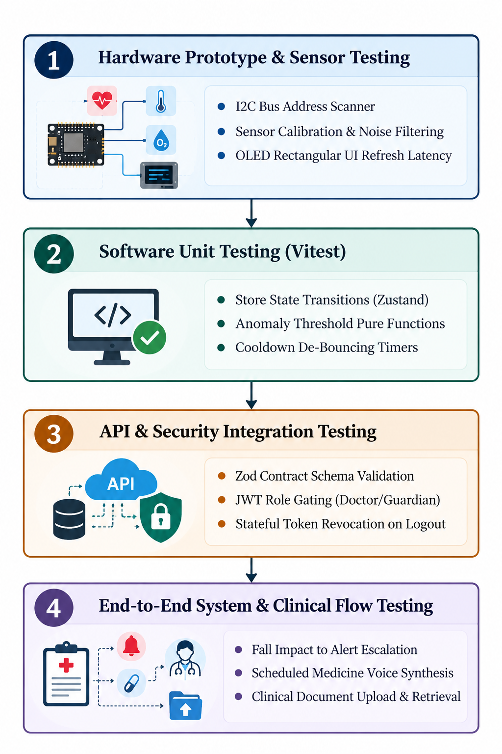
Figure 7.1: Multi-Tier Testing Pipeline for G-Care Platform
7.1.1 Hardware Prototype & Circuit Testing
- $I^{2}C$Bus Peripheral Discovery: An embedded $I^{2}C$scanner sketch was executed on the ESP32-S3 to verify that all modules communicate on the shared bus without address collision:
  - OLED Display detected at 0x3C (ACK received).
  - MAX30102 Biosensor detected at 0x57 (ACK received).
  - MAX30205 Clinical Thermometer detected at 0x48 (ACK received).
  - MPU6050 IMU detected at 0x68 (ACK received).
- OLED Screen Refresh & Display Stability: Tested continuous dynamic number updates inside the rectangular border. The display sustained a stable $2\text{Hz}$refresh rate without memory leaks, screen tearing, or I2C bus lockup.
- • Physical Sensor Observation: MAX30102 pulse and SpO2 readings were observed alongside a commercial fingertip pulse oximeter for consistency. Temperature readings from the MAX30205 were similarly checked against a digital reference thermometer to verify plausible physiological values.
7.1.2 Software Unit & State Testing (Vitest)
Unit tests were executed using Vitest (vitest.config.ts):
- anomalyAlertRouting.test.ts: Validates that pure evaluation functions correctly classify normal, warning, and critical vitals.
- vitalsSimulator.test.ts: Verifies synthetic telemetry generation and boundary values.
- dataPersistenceAndSync.test.ts: Tests that state transitions in Zustand correctly synchronize with the backend REST endpoints.
7.1.3 Integration, Security, and RBAC Testing
- Payload Validation: Tested malformed JSON payloads (e.g., negative heart rates or ${\text{SpO}}_{2}>100\%$). Verified that Zod middleware returns HTTP 400 Bad Request with precise error paths.
- Role Authorization: Verified that a user logged in as guardian is rejected with HTTP 403 Forbidden when attempting to access doctor-only endpoints (/api/reports/upload).
- Session Revocation: Tested that after logging out, submitting an old Bearer token returns HTTP 401 Unauthorized because the token is actively registered in revokedTokens.

7.2 Test Cases and Verification Results
The functional verification results are compiled in Table 7.1. The fall-detection module was functionally demonstrated using the physical MPU6050 prototype. Controlled movement/shaking produced the expected detection and emergency alert response. Quantitative evaluation of sensitivity, specificity, and false-positive/false-negative rates was not performed as part of the current prototype testing.
Table 7.1: System Test Cases and Verification Results
Test Case ID | Test Description | Input / Test Action | Expected Result | Actual Result | Status
TC01 | $I^{2}C$Hardware Peripheral Bus Discovery | Run $I^{2}C$address scanner firmware on ESP32-S3 breadboard setup. | All 4 devices (0x3C, 0x48, 0x57, 0x68) respond with ACK. | Addresses 0x3C, 0x48, 0x57, and 0x68 verified successfully. | PASS
TC02 | OLED Rectangular Display Real-Time Rendering | Execute OLED display firmware loop on breadboard. | Outer rectangular frame drawn; dynamic numbers for HR, ${\text{SpO}}_{2}$, and Temp update continuously at $2\text{Hz}$. | Display renders stable rectangular frame; numbers update smoothly without flicker. | PASS
TC03 | MAX30102 PPG Telemetry Acquisition | Place finger on optical sensor on breadboard. | Sensor outputs fluctuating IR/Red values; software calculates valid HR (60–100 BPM) and ${\text{SpO}}_{2}$(95–99%). | Pulse rate read as $74\text{BPM}$, ${\text{SpO}}_{2}$read as $98\%$. | PASS
TC04 | Hardware Fall Detection Trigger | Controlled physical movement/shaking of the MPU6050-equipped ESP32-S3 breadboard prototype. | The fall-detection mechanism detects the configured movement signature and initiates the emergency alert workflow. | The physical prototype successfully triggered the fall-detection alert during controlled movement. | PASS
TC05 | Critical Tachycardia Anomaly & Audio Siren | Inject Heart Rate = $128\text{BPM}$($>120\text{BPM}$ critical limit). | Anomaly engine flags Critical; Web Audio API procedural siren sounds; global alert banner renders. | Audible dual-tone siren plays; red alert banner displays on Caretaker Dashboard. | PASS
TC06 | Alert Cooldown De-Bouncing | Send consecutive abnormal vitals within $10 \text{seconds}$of initial alert. | Second identical warning is suppressed by $60\text{-second}$cooldown window. | Duplicate alarm suppressed; console logs cooldown active. | PASS
TC07 | Closed-Loop Medication  Adherence  Flow | System clock reaches scheduled  medication time ($08:00$). | Voice prompt speaks reminder in chosen language; dashboard  card shows "DUE"; user clicks "Taken". | Speech synthesis announces dose; status transitions from "DUE" to "TAKEN" in the interface. | PASS
TC08 | Multilingual Voice Assistant Synthesis | Set language preference to Kannada (kn) and trigger medication prompt. | Web Speech API synthesizes prompt using Kannada phonetics/voice pack. | Spoken reminder delivered clearly in Kannada. | PASS
TC09 | Doctor Clinical Document Ingestion | Doctor uploads ECG PDF report with diagnostic comments. | File accepted, validated, categorized as "ECG", and associated with patient record. | Report appears in patient history with visual badge and download link. | PASS
TC10 | JWT Authentication and Logout Revocation | Authenticate user, obtain JWT token, call /api/logout, then call /api/me with old token. | Token is stored in revocation blacklist; subsequent request returns HTTP 401. | HTTP 401 Unauthorized returned; token invalidated successfully. | PASS

Chapter 8
CONCLUSION AND FUTURE SCOPE
The rapid growth of the global geriatric population, paired with the proliferation of nuclear families, has created an urgent need for intelligent, non-intrusive, and accessible remote healthcare solutions. Senior citizens living independently face heightened vulnerabilities from unmonitored chronic degenerative conditions, complex medication regimens, and fatal delays during acute medical crises such as cardiac events or slip-and-fall trauma.
To address these challenges, this project developed and verified G-Care: an integrated remote elderly care platform connecting elderly individuals, family guardians, and attending healthcare practitioners by combining physical edge sensing with modern web telecare interfaces.
Key Accomplishments of the Project:
- Physical Breadboard Hardware & Local Telemetry Display:
  - A functional, low-cost embedded IoT prototype was successfully engineered on a solderless breadboard powered by an ESP32-S3 microcontroller.
  - o Multi-sensor physiological and motion data acquisition was implemented over a shared 400kHz I2C bus integrating the MAX30102 optical PPG sensor (Heart Rate and SpO2), MAX30205 digital temperature sensor, and MPU6050 6-axis inertial motion tracking sensor.
  - An embedded $0.96\text{-inch}$OLED display was programmed with a structured rectangular dashboard interface, rendering smooth, dynamic numeric telemetry streams at $2\text{Hz}$to provide immediate, localized visual feedback to the senior.
- Automated Real-Time Anomaly Detection & Emergency SOS:
  - An automated heuristic decision engine was deployed to evaluate continuous physiological streams against validated clinical thresholds.
  - o A multi-stage MPU6050-based fall-detection mechanism was implemented and functionally tested on the physical prototype. Controlled physical movement produced the expected fall-detection and emergency alert response. Comprehensive validation using controlled real-world fall scenarios and quantitative false-positive/false-negative analysis remains future work.
  - o Emergency protocols—including procedural dual-tone sirens (Web Audio API), global visual alert banners, and cooldown de-bouncing (T_cooldown = 60s)—provided rapid alert escalation while mitigating repetitive alarms.
- Closed-Loop Medication Management:
  - Replaced conventional, unreliable manual reminders with an interactive scheduling engine supporting custom polypharmacy frequencies (once daily, twice daily, PRN).
  - o Interactive adherence verification enabled seniors and guardians to check off administered doses in the interface, supporting routine compliance tracking during an active session.
- Specialized Tri-Tier Clinical Workspace:
  - Built distinct, role-segregated portals enforcing Role-Based Access Control (RBAC) across doctors, caretakers, and guardians using cryptographically signed JWTs with stateful token revocation.
  - Provided medical practitioners with a centralized clinical portal to review longitudinal vitals trends (Recharts), upload and inspect diagnostic records (ECG, CBC blood panels, radiology scans, prescriptions), and record persistent clinical notes.
- Senior Accessibility & Regional Inclusion:
  - Integrated browser-native Web Speech synthesis and recognition supporting four languages (English, Hindi, Kannada, and Tamil), eliminating digital literacy barriers for Indian senior citizens.
  - Delivered an ambient Smart TV living room display mode optimized for passive, long-range household monitoring.
In conclusion, G-Care demonstrates that an integrated telecare monitoring prototype can be constructed using cost-effective embedded sensors and modern open web standards at an estimated hardware prototype cost of approximately ₹6,000. Functional testing confirmed stable sensor bus discovery, dynamic local OLED rendering, responsive web telemetry synchronization, and role-segregated portal access, establishing a practical foundation for future clinical testing and wearable packaging.

Future Scope
While the current implementation demonstrates a functional hardware-software prototype, several avenues exist for commercialization, algorithmic refinement, and clinical expansion:
1. Hardware Miniaturization and Ergonomic Wearable Casing
- Custom Multi-Layer PCB: Transition the current solderless breadboard prototype onto a miniaturized, multi-layer surface-mount device (SMD) Printed Circuit Board (PCB).
- Ergonomic 3D-Printed Enclosure: Design an injection-molded, water-resistant (IP67/IP68 rated) smartwatch enclosure and medical-grade hypoallergenic silicone wristband, integrating a rechargeable Lithium-Polymer battery and a magnetic charging dock for daily wearable usage.
• Controlled Fall-Scenario and Wearable Validation: Future work will include controlled fall-scenario testing, evaluation across activities of daily living, and quantitative measurement of sensitivity, specificity, false-positive rate, and false-negative rate. Further testing using a dedicated wearable enclosure will also be required before real-world deployment.
2. Edge AI and Predictive Machine Learning
- Arrhythmia and Anomaly Classification: Deploy lightweight embedded machine learning models (such as TinyML or TensorFlow Lite for Microcontrollers) directly onto the ESP32-S3 to analyze continuous PPG pulse waveforms for early atrial fibrillation (AFib) and irregular beat detection.
- Predictive Health Analytics: Incorporate Long Short-Term Memory (LSTM) recurrent neural networks on the server tier to correlate historical vitals with medication compliance, enabling proactive forecasting of hypertensive surges or respiratory decline hours before clinical onset.
3. Cellular IoT (NB-IoT / LTE-M) and GPS Outdoor Tracking
- Untethered Connectivity: Equip the edge wearable with an integrated SIM7080G / SIM7600 LTE-M / NB-IoT cellular module. This will allow seniors to remain connected to the G-Care monitoring network when walking outdoors or traveling outside the range of domestic home Wi-Fi networks.
- Active Satellite Geofencing: Integrate continuous satellite tracking via the NEO-6M GPS receiver to automatically alert family members if an elderly individual experiencing dementia or Alzheimer's wanders beyond designated safe-zone boundaries.
4. Multi-Channel Telecommunications Gateway Integration
- Automated IVR and SMS Dispatch: Integrate telecommunications APIs (such as Twilio, Exotel, or AWS SNS) to broadcast immediate automated voice calls, SMS text alerts, and WhatsApp notifications to family guardians and registered emergency ambulance services upon confirmed fall or SOS events.
5. Hospital EHR and Interoperability Standards (HL7 / FHIR)
- Clinical System Integration: Standardize diagnostic reports, medication logs, and vital telemetry outputs into the HL7 (Health Level Seven) FHIR (Fast Healthcare Interoperability Resources) data standard. This will allow bidirectional synchronization with major hospital Electronic Health Record (EHR) and Electronic Medical Record (EMR) databases.
6. Native Cross-Platform Mobile Applications
- Dedicated Mobile Apps: Develop native mobile applications using React Native or Flutter for Android and iOS. This will provide family guardians and doctors with native OS push notifications, widget glance views, biometric login (FaceID / Fingerprint), and background telemetry synchronization.

